Sprawozdanie

Lab. 3

# Zadanie 1

## Zaprojektować układ realizujący przy pomocy dostępnych bramek logicznych funkcję: y = ∑ [0,1,2,6,8,10,11,12; (4,14)].

|  |  |  |  |  |  |
| --- | --- | --- | --- | --- | --- |
|  | **A** | **B** | **C** | **D** |  |
| **0** | 0 | 0 | 0 | 0 | 1 |
| **1** | 0 | 0 | 0 | 1 | 1 |
| **2** | 0 | 0 | 1 | 0 | 1 |
| **3** | 0 | 0 | 1 | 1 | 0 |
| **4** | 0 | 1 | 0 | 0 | - |
| **5** | 0 | 1 | 0 | 1 | 0 |
| **6** | 0 | 1 | 1 | 0 | 1 |
| **7** | 0 | 1 | 1 | 1 | 0 |
| **8** | 1 | 0 | 0 | 0 | 1 |
| **9** | 1 | 0 | 0 | 1 | 0 |
| **10** | 1 | 0 | 1 | 0 | 1 |
| **11** | 1 | 0 | 1 | 1 | 1 |
| **12** | 1 | 1 | 0 | 0 | 1 |
| **13** | 1 | 1 | 0 | 1 | 0 |
| **14** | 1 | 1 | 1 | 0 | - |
| **15** | 1 | 1 | 1 | 1 | 0 |

|  |  |  |  |  |  |
| --- | --- | --- | --- | --- | --- |
|  | | **CD** | | | |
| **00** | **01** | **11** | **10** |
| **AB** | **00** | 1 | 1 | 0 | 1 |
| **01** | - | 0 | 0 | 1 |
| **11** | 1 | 0 | 0 | - |
| **10** | 1 | 0 | 1 | 1 |

|  |  |  |  |
| --- | --- | --- | --- |
| **A** | **B** | **C** | **D** |
| 0 | 0 | 0 | 0 |
| 0 | 1 | 0 | 0 |
| 1 | 1 | 0 | 0 |
| 1 | 0 | 0 | 0 |
| 0 | 0 | 1 | 0 |
| 0 | 1 | 1 | 0 |
| 1 | 1 | 1 | 0 |
| 1 | 0 | 1 | 0 |
|  |  |  |  |

|  |  |  |  |
| --- | --- | --- | --- |
| **A** | **B** | **C** | **D** |
| 0 | 0 | 0 | 0 |
| 0 | 0 | 0 | 1 |
|  |  |  |  |

|  |  |  |  |
| --- | --- | --- | --- |
| **A** | **B** | **C** | **D** |
| 1 | 0 | 1 | 1 |
| 1 | 0 | 1 | 0 |
| **A** | $$\overline{B}$$ | **C** |  |

### A)

$$X=\overline{D}+\overline{A}\overline{B}\overline{C}+A\overline{B}C$$

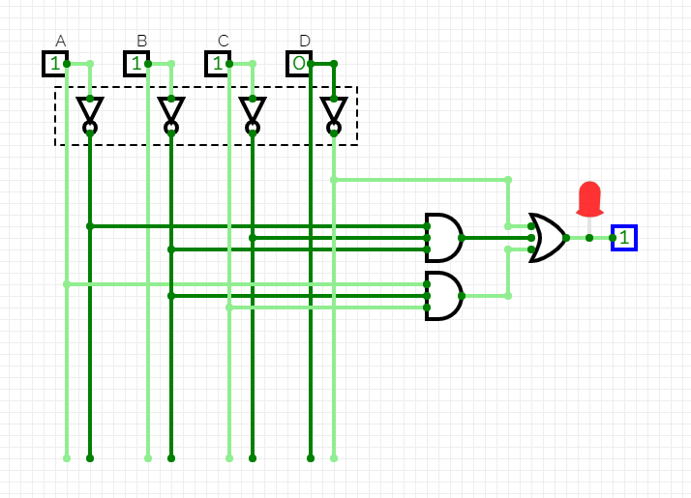

### C)

$$X=\overset{̿}{\overline{D}+\overline{A}\overline{B}\overline{C}+A\overline{B}C}=\overline{\overset{̿}{D}×\overline{\overline{A}\overline{B}\overline{C}}×\overline{A\overline{B}C}}$$

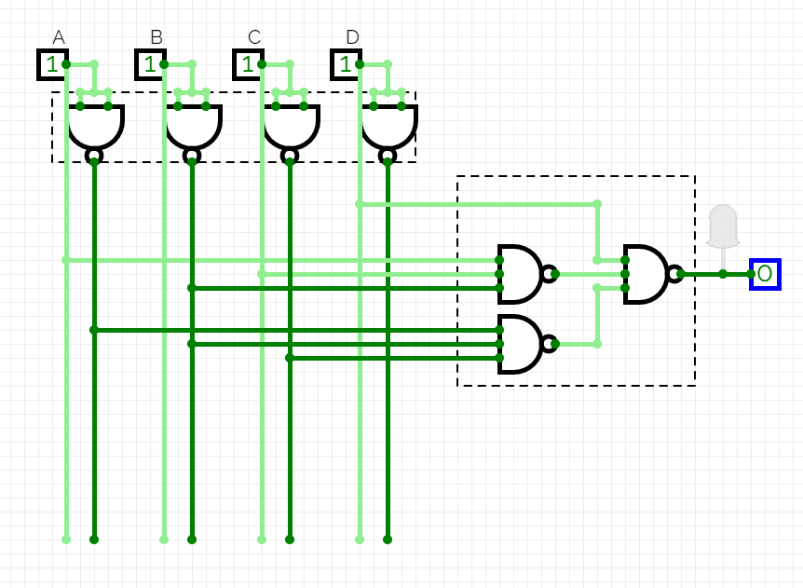

# Zadanie 2

## Zaprojektować układ realizujący przy pomocy dostępnych bramek logicznych funkcję: y = ∑ [0,3,5,12,15; (1,2,4,7,8,11,13,14)].

|  |  |  |  |  |  |
| --- | --- | --- | --- | --- | --- |
|  | **A** | **B** | **C** | **D** |  |
| **0** | 0 | 0 | 0 | 0 | 1 |
| **1** | 0 | 0 | 0 | 1 | - |
| **2** | 0 | 0 | 1 | 0 | - |
| **3** | 0 | 0 | 1 | 1 | 1 |
| **4** | 0 | 1 | 0 | 0 | - |
| **5** | 0 | 1 | 0 | 1 | 1 |
| **6** | 0 | 1 | 1 | 0 | 0 |
| **7** | 0 | 1 | 1 | 1 | - |
| **8** | 1 | 0 | 0 | 0 | - |
| **9** | 1 | 0 | 0 | 1 | 0 |
| **10** | 1 | 0 | 1 | 0 | 0 |
| **11** | 1 | 0 | 1 | 1 | - |
| **12** | 1 | 1 | 0 | 0 | 1 |
| **13** | 1 | 1 | 0 | 1 | - |
| **14** | 1 | 1 | 1 | 0 | - |
| **15** | 1 | 1 | 1 | 1 | 1 |

### D)

|  |  |  |  |  |  |
| --- | --- | --- | --- | --- | --- |
|  | | **CD** | | | |
| **00** | **01** | **11** | **10** |
| **AB** | **00** | 1 | - | 1 | - |
| **01** | - | 1 | - | 0 |
| **11** | 1 | - | 1 | - |
| **10** | - | 0 | - | 0 |

|  |  |  |  |
| --- | --- | --- | --- |
| **A** | **B** | **C** | **D** |
| 1 | 0 | 0 | 0 |
| 1 | 0 | 0 | 1 |
| 1 | 0 | 1 | 1 |
| 1 | 0 | 1 | 0 |
| $$\overline{A}$$ | **B** |  |  |
| **A** | **B** | **C** | **D** |
| 0 | 0 | 1 | 0 |
| 0 | 1 | 1 | 0 |
| 1 | 1 | 1 | 0 |
| 1 | 0 | 1 | 0 |
|  |  | $$\overline{C}$$ | **D** |

$$X=\left(\overline{A}+B\right)×\left(\overline{C}+D\right)$$

$$\overset{̿}{\left(\overline{A}+B\right)×\left(\overline{C}+D\right)}=\overline{\overline{\left(\overline{A}+B\right)}+\overline{\left(\overline{C}+D\right)}}$$

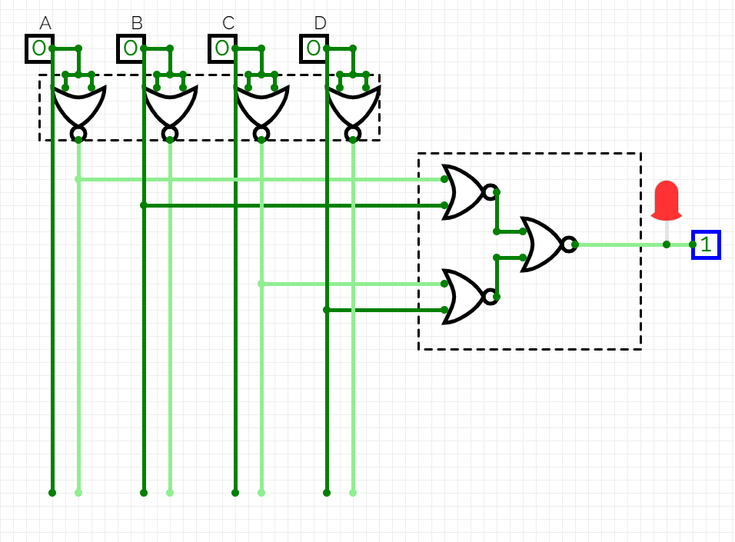

# Zadanie 3

## Zaprojektować układ realizujący przy pomocy dostępnych bramek logicznych funkcję: y = ∑ [1,4,9,10,13,15; (2,8)].

|  |  |  |  |  |  |
| --- | --- | --- | --- | --- | --- |
|  | **A** | **B** | **C** | **D** |  |
| **0** | 0 | 0 | 0 | 0 | 0 |
| **1** | 0 | 0 | 0 | 1 | 1 |
| **2** | 0 | 0 | 1 | 0 | - |
| **3** | 0 | 0 | 1 | 1 | 0 |
| **4** | 0 | 1 | 0 | 0 | 1 |
| **5** | 0 | 1 | 0 | 1 | 0 |
| **6** | 0 | 1 | 1 | 0 | 0 |
| **7** | 0 | 1 | 1 | 1 | 0 |
| **8** | 1 | 0 | 0 | 0 | - |
| **9** | 1 | 0 | 0 | 1 | 1 |
| **10** | 1 | 0 | 1 | 0 | 1 |
| **11** | 1 | 0 | 1 | 1 | 0 |
| **12** | 1 | 1 | 0 | 0 | 0 |
| **13** | 1 | 1 | 0 | 1 | 1 |
| **14** | 1 | 1 | 1 | 0 | 0 |
| **15** | 1 | 1 | 1 | 1 | 1 |

### C)

|  |  |  |  |  |  |
| --- | --- | --- | --- | --- | --- |
|  | | **CD** | | | |
| **00** | **01** | **11** | **10** |
| **AB** | **00** | 0 | 1 | 0 | - |
| **01** | 1 | 0 | 0 | 0 |
| **11** | 0 | 1 | 1 | 0 |
| **10** | - | 1 | 0 | 1 |

|  |  |  |  |
| --- | --- | --- | --- |
| **A** | **B** | **C** | **D** |
| 0 | 0 | 0 | 1 |
| 1 | 0 | 0 | 1 |
|  | $$\overline{B}$$ | $$\overline{C}$$ | **D** |

|  |  |  |  |
| --- | --- | --- | --- |
| **A** | **B** | **C** | **D** |
| 1 | 0 | 0 | 0 |
| 1 | 0 | 1 | 0 |
| **A** |  |  |  |

|  |  |  |  |
| --- | --- | --- | --- |
| **A** | **B** | **C** | **D** |
| 0 | 1 | 0 | 0 |
| $$\overline{A}$$ | **B** |  |  |

|  |  |  |  |
| --- | --- | --- | --- |
| **A** | **B** | **C** | **D** |
| 1 | 1 | 0 | 1 |
| 1 | 1 | 1 | 1 |
| **A** | **B** |  | **D** |

$$X=ABD+\overline{B}\overline{C}D+\overline{A}B\overline{C}\overline{D}+A\overline{B}\overline{D}$$

$$\overset{̿}{ABD+\overline{B}\overline{C}D+\overline{A}B\overline{C}\overline{D}+A\overline{B}\overline{D}}=\overline{\overline{ABD}+\overline{\overline{B}\overline{C}D}+\overline{\overline{A}B\overline{C}\overline{D}}+\overline{A\overline{B}\overline{D}}}$$

